

Assignment

**Assignment Name :**  Effects of Facebook among young generation of Bangladesh

**Course Title:**  Bangladesh Studies

**Course Code: BNS 101**

**Submitted to:**

**Rafi Al Mahmud**

Assistant Professor

Department of Development Studies

Daffodil International University

**Submitted By**

**Name:** MD. Sazzadul Islam Shaon

**ID:**  0242310005101028

**Section:** 64_B

Department of CSE

Daffodil International University

| **Date of Submission:** 12/03/2024 |
| --- |

**“Effects of Facebook among young generation of Bangladesh”**

**Facebook in bangladesh**

Facebook is a social media platform. It connects people around the globe. According to report , Facebook became available in Bangladesh around 2008-2009. As per May 2023, 59 million people use Facebook in Bangladesh. The young generation (aged 14-40) makes up a significant portion of this user base. That’s why Facebook has a huge impact among the youth.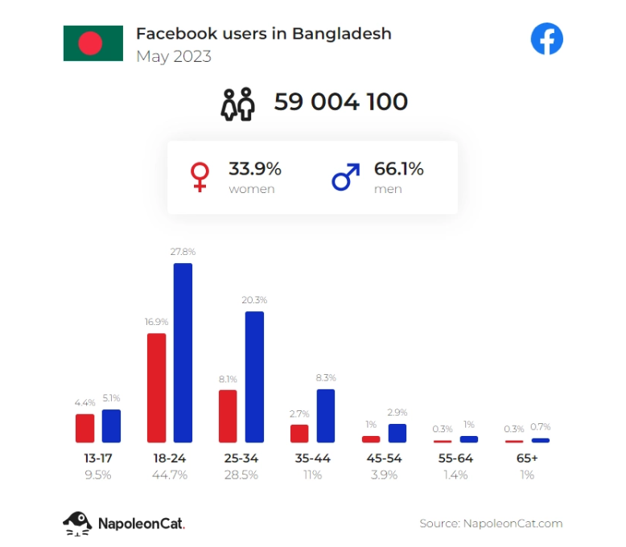

**The effect of Facebook among the youth**

In the ever-evolving digital landscape of Bangladesh, the pervasive influence of social media platforms like Facebook has become a defining feature of the lives of its teenagers. Most of the youth can’t live without Facebook. They spend on average 6-8 hours a day surfing on Facebook newsfeed. That’s why Facebook has a great effect on their lives and mentality.

**The Positive effects**

* **Connections and Communication** : Social media, with its dynamic and interactive nature, has provided Bangladeshi teenagers with an unprecedented platform for global exposure and connection. Through these channels, they are able to engage with diverse cultures and perspectives.
* **Education and Learning** : There are many Facebook communities who help others with valuable educational resources. With that, youth can learn many things for free and grow their skills.
* **Entrepreneurship and Business** : Nowadays most of the young stars choose Facebook to start and grow their businesses. Facebook is free to use and most of the targeted customers use facebook which helps them to grow.
* **Social Awareness** : Facebook helps youth to spread social awareness about many important issues.

**The negative effects**

* **Cyberbullying and Online harassment** : Nowadays It’s a matter of concern that cyberbullying and online harassment have become an important issue. The anonymity of online interactions is the main cause of these.
* **Misinformation and Fake News** : Spreading misinformation and fake news is also a major issue. People are sharing fake news without knowing the truth and some common people are leading their life in danger believing those.
* **Addiction** : Youths are getting addicted to Facebook too much which is harmful for their physical and mental health. They are using 6-8 hours a day. That also affects their study.
* **Privacy Concern** : Every social media including Facebook has major flows in terms of privacy. People are sharing everything happening in their lives. Which lets others know everything about them. Also data leaks, selling users data also affecting people’s privacy.

*Sources*

**“Does Facebook affect student life in Bangladesh?” *Dhaka Tribune*, 2 January 2020,** https://www.dhakatribune.com/opinion/op-ed/197746/does-facebook-affect-student-life-in-bangladesh. Accessed 12 March 2024.

**Pokrop, Jasiek. “Facebook users in Bangladesh in 2023.” *NapoleonCat*, 16 June 2023**, https://napoleoncat.com/blog/facebook-users-in-bangladesh/. Accessed 12 March 2024.

**Serajuddin, Mohammad. “The dual impact of social media on Bangladeshi teenagers: A linguistic perspective.” *Dhaka Tribune*,** 24 October 2023, https://www.dhakatribune.com/feature/youth/328954/the-dual-impact-of-social-media-on-bangladeshi. Accessed 12 March 2024.